**Chapter 4**

**Differentiation of Functions of Several Variables**

**4.6 Directional Derivatives and the Gradient**

**Section Exercises**

**For the following exercises, find the directional derivative using the limit definition only.**

1.  at point  in the direction of 

Answer: 

1.  at point  in the direction of 

Answer: 

1. Find the directional derivative of  at point  in the direction of .

Answer: 

**For the following exercises, find the directional derivative of the function at point in the direction of **

1.   

Answer: 

1. 

Answer: 

1. 

Answer: 

1. 

Answer: 

1. 

Answer: 

1. 

Answer: 

1. 

Answer: 

1. 

Answer: 

1. 

Answer: 

1. 

Answer: 

1. 

Answer: 

**For the following exercises, find the directional derivative of the function in the direction of the unit vector **

1. 

Answer: 

1. 

Answer: 

1. 

Answer: 

1. 

Answer: 

1. 

Answer: 

1. 

Answer: 

**For the following exercises, find the gradient**.

1. Find the gradient of  Then, find the gradient at point 

Answer:  

1. Find the gradient of  at point 

Answer: 

1. Find the gradient of  at  and in the direction of 

Answer: 

1. 

Answer: 

**For the following exercises, find the directional derivative of the function at point  in the direction of **

1. 

Answer: 

1. 

Answer: 

**For the following exercises, find the derivative of the function at  in the direction of.**

1. 

Answer: 

1. 

Answer: 

1. **[T]** Use technology to sketchthe level curve of  that passes through  and draw the gradient vector at 

Answer:

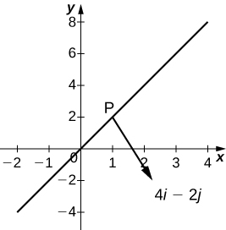

1. **[T]** Use technology to sketchthe level curve of  that passes through  and draw the gradient vector at 

Answer:

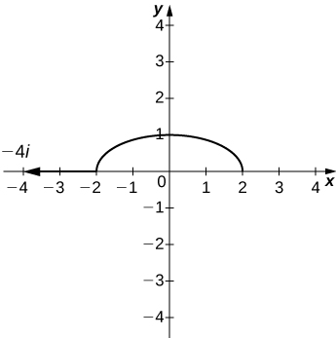

**For the following exercises, find the gradient vector at the indicated point.**

1. 

Answer: 

1. 

Answer: 

1. 

Answer:

1. 

Answer: 

**For the following exercises, find the derivative of the function.**

1.  at point in the direction the function increases most rapidly

Answer: 

1.  at point  in the direction the function increases most rapidly

Answer: 

1.  at point  in the direction the function increases most rapidly

Answer: 

1.  at point  in the direction the function increases most rapidly

Answer: 

1.  at point  in the direction the function increases most rapidly

Answer: 

**For the following exercises, find the maximum rate of change of  at the given point and the direction in which it occurs.**

1.  

Answer: 

1.  

Answer: 

1. 

Answer: 

**For the following exercises, find equations of**

1. **the tangent plane and**
2. **the normal line to the given surface at the given point**.
3. The level curve  for  at point 

Answer: a.  b. 

1.  at point 

Answer: a.  b. 

1.  at point 

Answer: a.  b. 

1.  at point 

Answer: a.  b. 

**For the following exercises, solve the problem.**

1. The temperature  in a metal sphere is inversely proportional to the distance from the center of the sphere (the origin: The temperature at point  is 
   1. Find the rate of change of the temperature at point  in the direction toward point 
   2. Show that, at any point in the sphere, the direction of greatest increase in temperature is given by a vector that points toward the origin.

Answer: a.  b. Answers may vary

1. The electrical potential (voltage) in a certain region of space is given by the function 
2. Find the rate of change of the voltage at point  in the direction of the vector 
3. In which direction does the voltage change most rapidly at point 
4. What is the maximum rate of change of the voltage at point 

Answer: a.  b.  c. 

1. If the electric potential at a point  in the *xy*-plane is  then the electric intensity vector at  is 
2. Find the electric intensity vector at 
3. Show that, at each point in the plane, the electric potential decreases most rapidly in the direction of the vector 

Answer: a. 

1. In two dimensions, the motion of an ideal fluid is governed by a velocity potential  The velocity components of the fluid  in the *x-*direction and  in the *y*-direction, are given by  Find the velocity components associated with the velocity potential 

Answer: 

This file is copyright 2016, Rice University. All Rights Reserved.